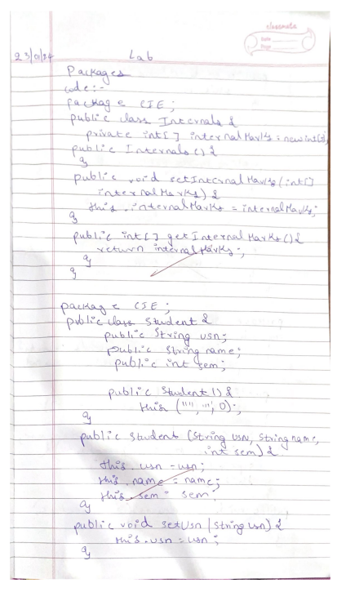

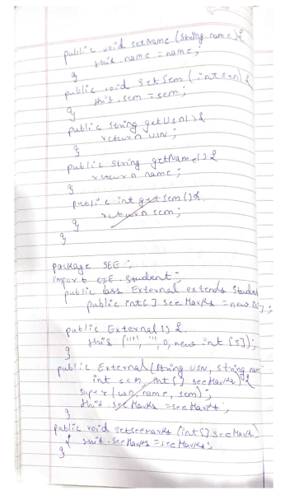

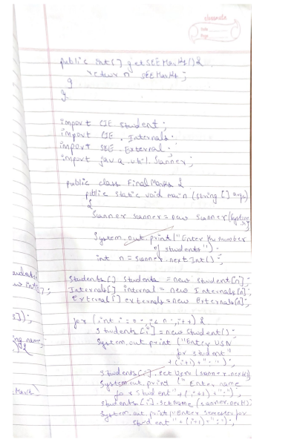

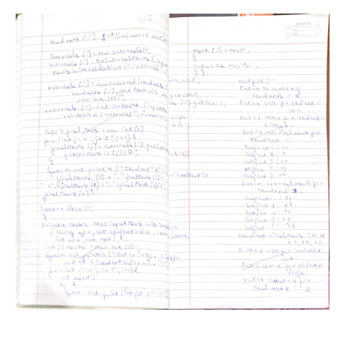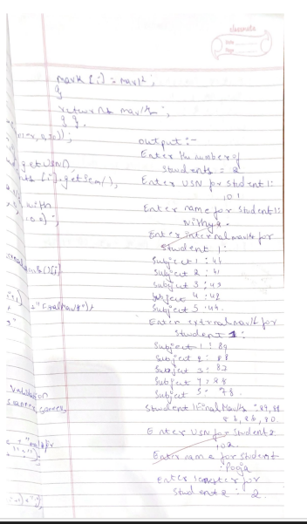

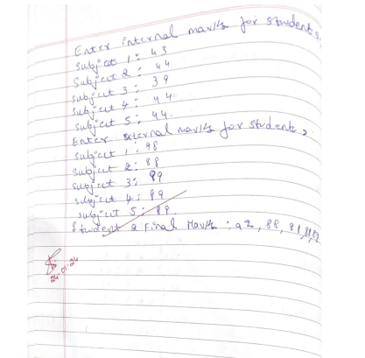

Code:-

package CIE;  
  
public class Internals {  
    private int[] internalMarks = new int[5];  
  
  
    public Internals() {  
       
    }  
  
     
    public void setInternalMarks(int[] internalMarks) {  
        this.internalMarks = internalMarks;  
    }  
  
     
    public int[] getInternalMarks() {  
        return internalMarks;  
    }  
}

package CIE;  
  
public class Student {  
    public String usn;  
    public String name;  
    public int sem;  
  
     
    public Student() {  
        this("", "", 0);  
    }  
  
  
    public Student(String usn, String name, int sem) {  
        this.usn = usn;  
        [this.name](http://this.name/) = name;  
        this.sem = sem;  
    }  
  
     
    public void setUsn(String usn) {  
        this.usn = usn;  
    }  
  
    public void setName(String name) {  
        [this.name](http://this.name/) = name;  
    }  
  
    public void setSem(int sem) {  
        this.sem = sem;  
    }  
  
     
    public String getUsn() {  
        return usn;  
    }  
  
    public String getName() {  
        return name;  
    }  
  
    public int getSem() {  
        return sem;  
    }  
}

package SEE;  
import CIE.Student;  
  
public class External extends Student {  
    public int[] seeMarks = new int[5];

public External() {  
        this("", "", 0, new int[5]);  
    }

  public External(String usn, String name, int sem, int[] seeMarks) {  
        super(usn, name, sem);  
        this.seeMarks = seeMarks;  
    }

public void setSeeMarks(int[] seeMarks) {  
        this.seeMarks = seeMarks;  
    }

 public int[] getSeeMarks() {  
        return seeMarks;  
    }  
}

import CIE.Student;  
import CIE.Internals;  
import SEE.External;  
import java.util.Scanner;  
  
public class FinalMarks {  
    public static void main(String[] args) {  
        Scanner scanner = new Scanner(System.in);  
  
        // Allow the user to enter the number of students  
        System.out.print("Enter the number of students: ");  
        int n = scanner.nextInt();  
  
        Student[] students = new Student[n];  
        Internals[] internals = new Internals[n];  
        External[] externals = new External[n];  
  
        // Initialize students, internals, and externals  
        for (int i = 0; i < n; i++) {  
            students[i] = new Student();  
            System.out.print("Enter USN for student " + (i + 1) + ": ");  
            students[i].setUsn(scanner.next());  
  
            System.out.print("Enter name for student " + (i + 1) + ": ");  
            students[i].setName(scanner.next());  
  
            System.out.print("Enter semester for student " + (i + 1) + ": ");  
            students[i].setSem(scanner.nextInt());  
  
            internals[i] = new Internals();  
            // Assuming a simple method to input internal marks with validation  
            internals[i].setInternalMarks(inputMarksWithValidation("internal", i, scanner, 0, 50));  
  
            externals[i] = new External(students[i].getUsn(), students[i].getName(), students[i].getSem(), new int[5]);  
            // Assuming a simple method to input external marks with validation  
            externals[i].setSeeMarks(inputMarksWithValidation("external", i, scanner, 0, 100));  
  
            // Calculate final marks for the ith student and display  
            int[] finalMarks = new int[5];  
            for (int j = 0; j < 5; j++) {  
                finalMarks[j] = internals[i].getInternalMarks()[j] + externals[i].getSeeMarks()[j] / 2;  
            }  
  
            System.out.println("Student " + (i + 1) + " Final Marks: " +  
                    finalMarks[0] + ", " + finalMarks[1] + ", " + finalMarks[2] + ", " +  
                    finalMarks[3] + ", " + finalMarks[4]);  
        }  
  
        scanner.close();  
    }  
  
    private static int[] inputMarksWithValidation(String type, int studentIndex, Scanner scanner, int min, int max) {  
        int[] marks = new int[5];  
        System.out.println("Enter " + type + " marks for student " + (studentIndex + 1) + ": ");  
        for (int i = 0; i < 5; i++) {  
            int mark;  
            do {  
                System.out.print("Subject " + (i + 1) + ": ");  
                mark = scanner.nextInt();  
                if (mark < 0 || mark > max) {  
                    System.out.println("Invalid input. " + type + " marks should be between 0 and " + max + ". Please try again.");  
                }  
            } while (mark < 0 || mark > max);  
            marks[i] = mark;  
        }  
        return marks;  
    }  
}

output:-

